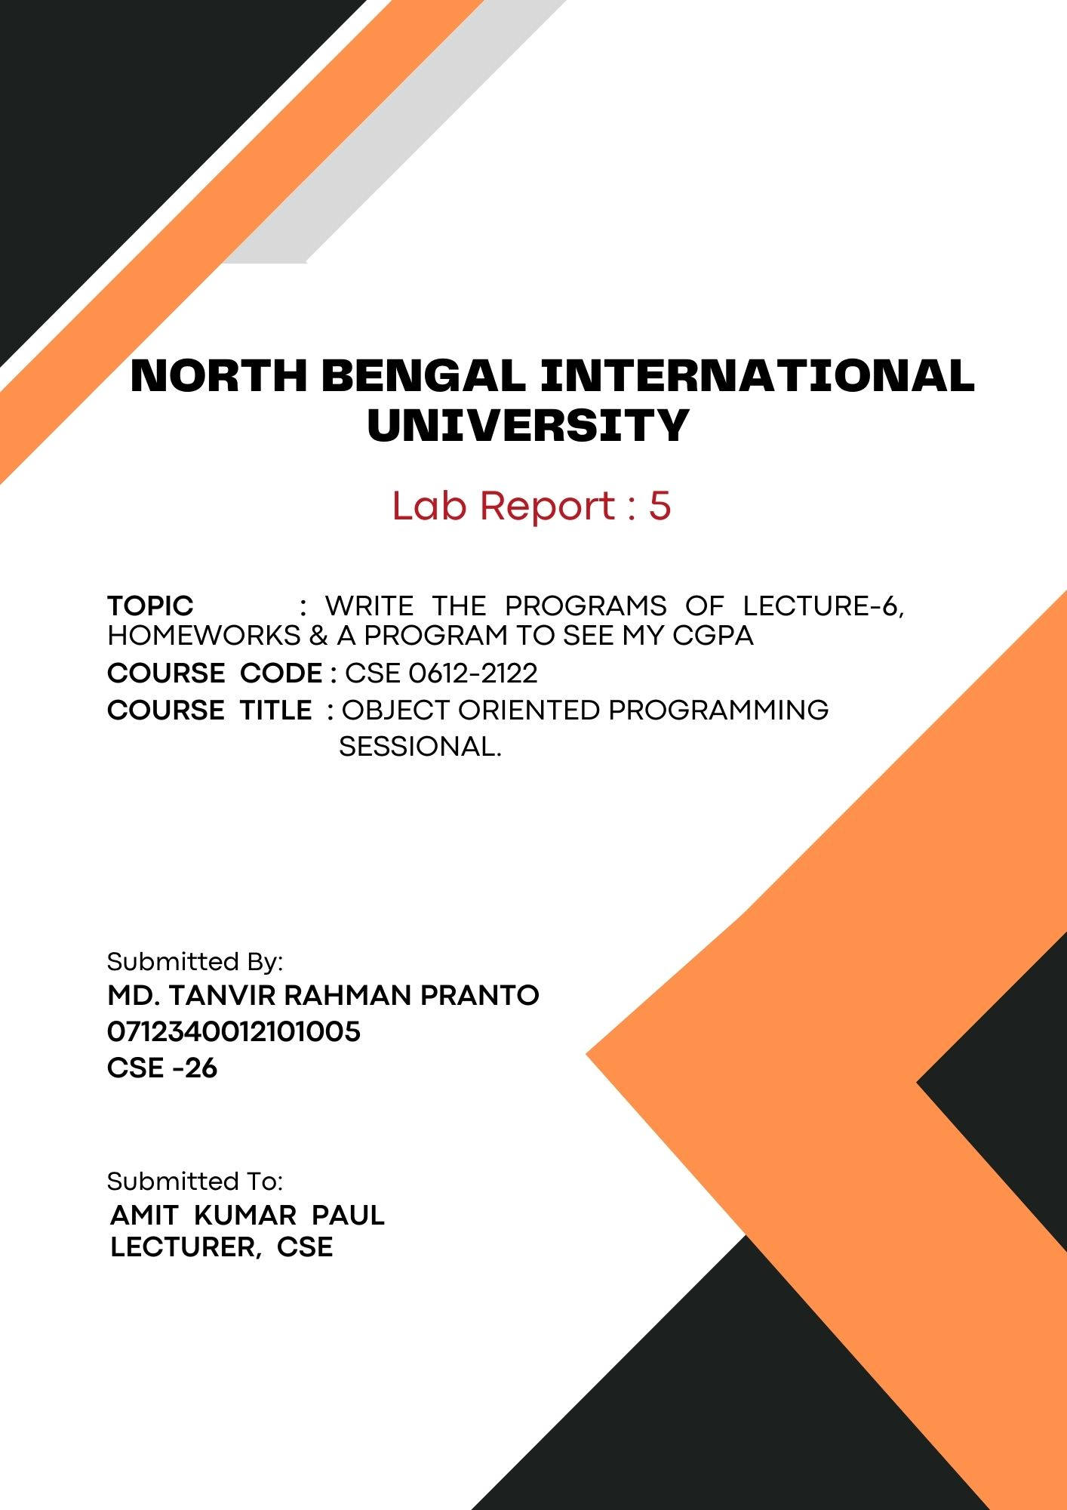
1

Write a program of lecture-6, Homework & a program to see my cgpa:

# Single inheritance:
Code:
#include <iostream>
using namespace std;

// Base class
class Person {
public:
void display() {
cout << "This is a person." << endl;
}
};

// Derived class
class Student : public Person {
public:
void study() {
cout << "The student is studying." << endl;
}
};

int main() {
Student myStudent;

myStudent.display();

myStudent.study();

return 0;
}

Output:
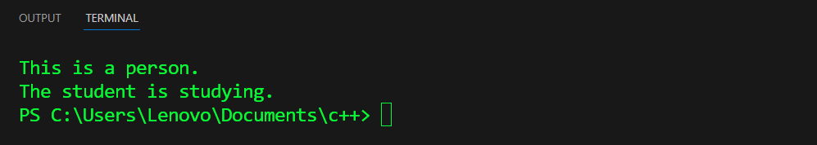

# Multilevel inheritance:
Code:
#include <iostream>
using namespace std;
// Base class
class Device {

public:
void powerOn() {
cout << "Device powered on." << endl;
}
};

// Derived class from Device
class Computer : public Device {
public:
void boot() {
cout << "Windows booting up." << endl;
}
};

// Derived class from Computer
class Laptop : public Computer {
public:
void ssd() {
cout << "This Laptop has a fast ssd." << endl;
}
};

int main() {
Laptop myLaptop;

myLaptop.powerOn();

myLaptop.boot();

myLaptop.ssd();

return 0;
}

Output:


# Multiple inheritance:
Code:
#include <iostream>
using namespace std;

class Printer {
public:
void print() {
cout << "Printing document." << endl;
}
};

class Scanner {
public:
void scan() {
cout << "Scanning document." << endl;
}
};

// Derived class
class AllInOne : public Printer, public Scanner {
public:
void fax() {
cout << "Sending fax." << endl;
}
};

int main() {
AllInOne myDevice;

myDevice.print();
myDevice.scan();

myDevice.fax();

return 0;
}

Output:


# Multiple inheritance:
Code:
#include <iostream>
using namespace std;

// Base class 1
class Person {
public:
void walk() {
cout << "Person is walking." << endl;
}
};

// Base class 2
class Worker {
public:
void work() {
cout << "Worker is working." << endl;
}
};

// Derived class inheriting from both Person and Worker
class Engineer : public Person, public Worker {
public:
void design() {
cout << "Engineer is designing." << endl;
}
};

// Another base class
class Artist {
public:
void draw() {
cout << "Artist is drawing." << endl;
}
};

// Derived class inheriting from Engineer and Artist
class Architect : public Engineer, public Artist {
public:
void build() {
cout << "Architect is building." << endl;
}
};

int main() {
Architect myArchitect;

// Calling base class functions
myArchitect.walk();
myArchitect.work();
myArchitect.design();
myArchitect.draw();
myArchitect.build();

return 0;
}

Output:
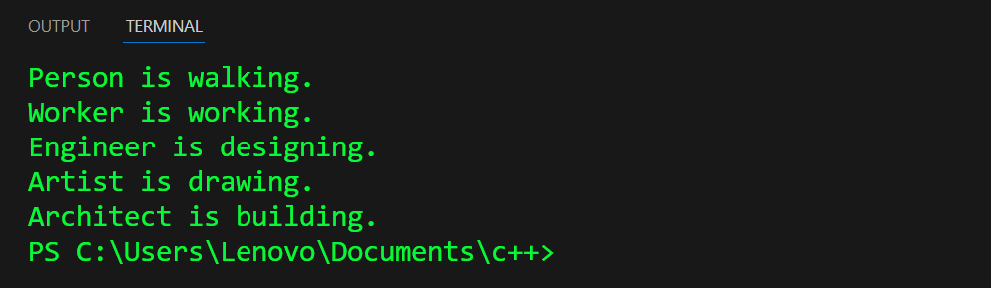

# Hierarchical inheritance:
Code:
#include <iostream>
using namespace std;

// Base class
class Shape {
public:
void draw() {
cout << "Drawing a shape." << endl;
}
};

// Derived class 1
class Circle : public Shape {
public:
void draw() {
cout << "Drawing a circle." << endl;
}
};

// Derived class 2
class Rectangle : public Shape {
public:
void draw() {
cout << "Drawing a rectangle." << endl;
}
};

// Derived class 3
class Triangle : public Shape {
public:
void draw() {
cout << "Drawing a triangle." << endl;
}
};

int main() {
Circle myCircle;
Rectangle myRectangle;
Triangle myTriangle;

// Calling base class function through derived classes
myCircle.draw();
myRectangle.draw();
myTriangle.draw();

return 0;
}

Output:
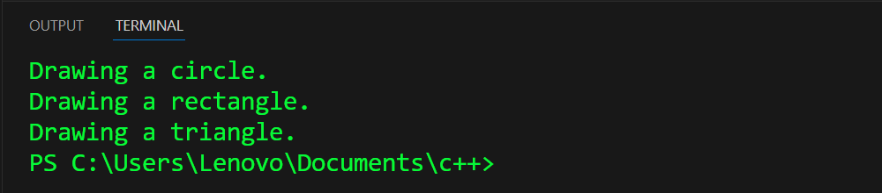

# Polymorphism:
Code:
#include <iostream>
using namespace std;

// Base class
class Employee {
public:
virtual void work() {
cout << "Employee is working." << endl;
}
};

// Derived class 1
class Manager : public Employee {
public:
void work() override {
cout << "Manager is managing." << endl;
}
};

// Derived class 2
class Engineer : public Employee {
public:
void work() override {
cout << "Engineer is developing." << endl;
}
};

// Derived class 3
class Intern : public Employee {
public:
void work() override {
cout << "Intern is learning." << endl;
}
};

void showWork(Employee &employee) {
employee.work();
}

int main() {
Manager myManager;
Engineer myEngineer;
Intern myIntern;

// Using a function that demonstrates polymorphism
showWork(myManager);
showWork(myEngineer);
showWork(myIntern);

return 0;
}

Output:
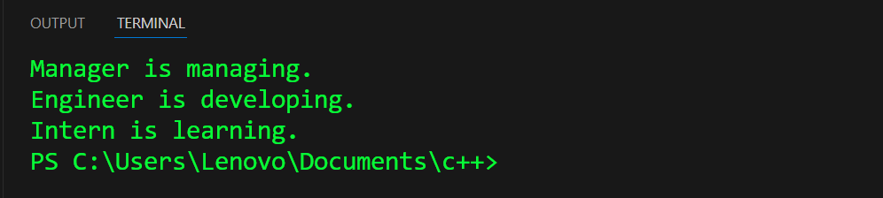

# Encapsulation:
Code:
#include <iostream>
using namespace std;

class Student {
private:
// Private data members
string name;
int rollNumber;

public:
// Constructor
Student(string studentName, int studentRollNumber) {
name = studentName;
rollNumber = studentRollNumber;
}

// Public method to get student's name
string getName() const {
return name;
}
// Public method to get student's roll number
int getRollNumber() const {
return rollNumber;
}
};

int main() {
// Create a Student object
Student myStudent("md.pranto", 005);

cout << "Student Name: " << myStudent.getName() << endl;
cout << "Student Roll Number: " << myStudent.getRollNumber() << endl;

return 0;
}

Output:
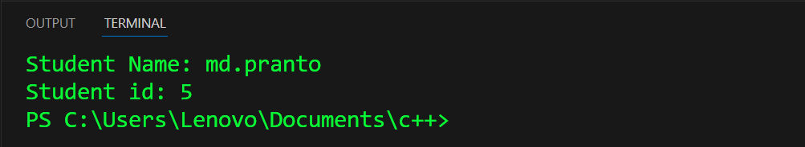

# Cgpa calculation:
Code:
#include <iostream>
using namespace std;

int main() {
int numberOfCourses;
cout << "Enter the total number of courses: ";
cin >> numberOfCourses;

int totalCredits = 0;
double totalGradePoints = 0;

for (int i = 0; i < numberOfCourses; ++i) {
int credits;
double gradePoint;
cout << "Enter credits for course " << i + 1 << ": ";
cin >> credits;
cout << "Enter grade point for course " << i + 1 << ": ";
cin >> gradePoint;

totalCredits += credits;
totalGradePoints += gradePoint * credits;
}

double cgpa = totalGradePoints / totalCredits;
cout << "The CGPA is: " << cgpa << endl;

return 0;
}

Output:
